


Sample Submission Form
XPS | VB-XPS | UPS | REELS | ISS | ARXPS

Client Information
Date: | Enter a date. | Affiliation Category: | Choose an item.
Name: | Enter text. | Institution / Company: | Enter text.
Email: | Enter text. | Department / Unit: | Enter text.
Tel.: | Enter text. | Position: | Choose an item.
 |  | P.I. / Manager: | Enter text.
Sample Information
►Total Number of Samples: | Enter a number. | ►Would you like your samples returned? |  | ►Contains iodine or tellurium?

No. | Sample ID / Name | Requested Technique | Required Analysis Details for the Specified Technique | Sample Type | Any Specific Handling/storage Instructions
1. | e.g., S1 or sample name | e.g., XPS, UPS | e.g., survey scan; high-resolution C 1s, O 1s, N 1s, P 2p, S 2p etc. | e.g., thin film, powder, pellet, etc. | Click or tap here to enter text.
2. | Enter sample ID / name | Enter technique | Enter requested regions / details | Enter sample type | Click or tap here to enter text.

*Please add more rows if required. Use one row per sample.

Sample Preparation and Safety Checklist
☐ Samples are fully dry, clean, clearly labelled, and securely packaged.
☐ Powders are sealed properly to prevent leakage or contamination during transfer.
☐ Any hazardous, toxic, reactive, biological, or radioactive materials have been clearly identified.
☐ The sample labels on the containers match the Sample IDs/Names listed in this form.

Submission notes and acknowledgement
- Please attach the completed form to your request email and include a printed copy with the sample package.
- Contact Dr. Rad Sadri (XPS Specialist) at the University of Calgary to discuss your requirements.
- Sample drop-off / pick-up: University Research Centre (URC), 3520 Research Way NW, Calgary, AB T2L 2K5.
Contact: rad.sadri@ucalgary.ca (Rad) | 403-399-1419

I confirm that the information provided above is accurate and that the submitted samples meet the stated sample compatibility and safety requirements, unless approved in advance by the University of Calgary AXEL team.
Submitted by: | Type full name | Date: | Enter a date.
Account String*:  (for UCalgary users only) | Include DeptID and Project Code.
* For External Academic, Startup / Industry, Government / Public Agency, and other clients, billing will be handled separately through the applicable service agreement.

Client Guide: Sample Requirements and XPS Capabilities
Accepted Sample Forms  Accepted sample forms include powders, pressed pellets, thin films/coatings on substrates, wafers or diced chips, foils, coupons, bulk solids, granules/particulates, flakes, fibers, membranes, carbon papers, porous solids/foams, and small 3D parts with at least one accessible flat area.  Samples must be fully dry, stable, and vacuum-compatible. Both conductive and insulating samples are acceptable; charge neutralization is available for insulating materials. | Instrument and Analytical Options  - Micro-focused monochromated X-ray source with Al Kα and Ag Lα options.  - Selectable analysis areas from approximately <200 µm to >900 µm; small-area spectroscopy may be used for features down to approximately 20 µm, depending on sample geometry, signal level, and analysis requirements.  - Monoatomic Ar⁺ and gas-cluster Ar⁺ ion sources are available for in-situ surface cleaning and depth profiling of suitable materials.  - Available analytical techniques include XPS, VB-XPS, UPS, REELS, ISS, ARXPS, and depth profiling.
What XPS Can Provide  X-ray Photoelectron Spectroscopy (XPS) is a powerful surface-analysis technique that provides quantitative elemental composition, chemical state, and electronic state information from the top ~1–10 nm of materials.  XPS can help identify and quantify surface elements, evaluate chemical states, assess oxidation states and bonding environments, detect surface contamination, and compare treated, coated, aged, or modified surfaces.  Typical materials analyzed: metals, oxides, ceramics, minerals, cement-based materials, glass/fiberglass, polymers/plastics, organic and inorganic materials, paper/wood-based materials, carbon materials, semiconductors, coatings, catalysts, composites, and biomaterials. | Instrument  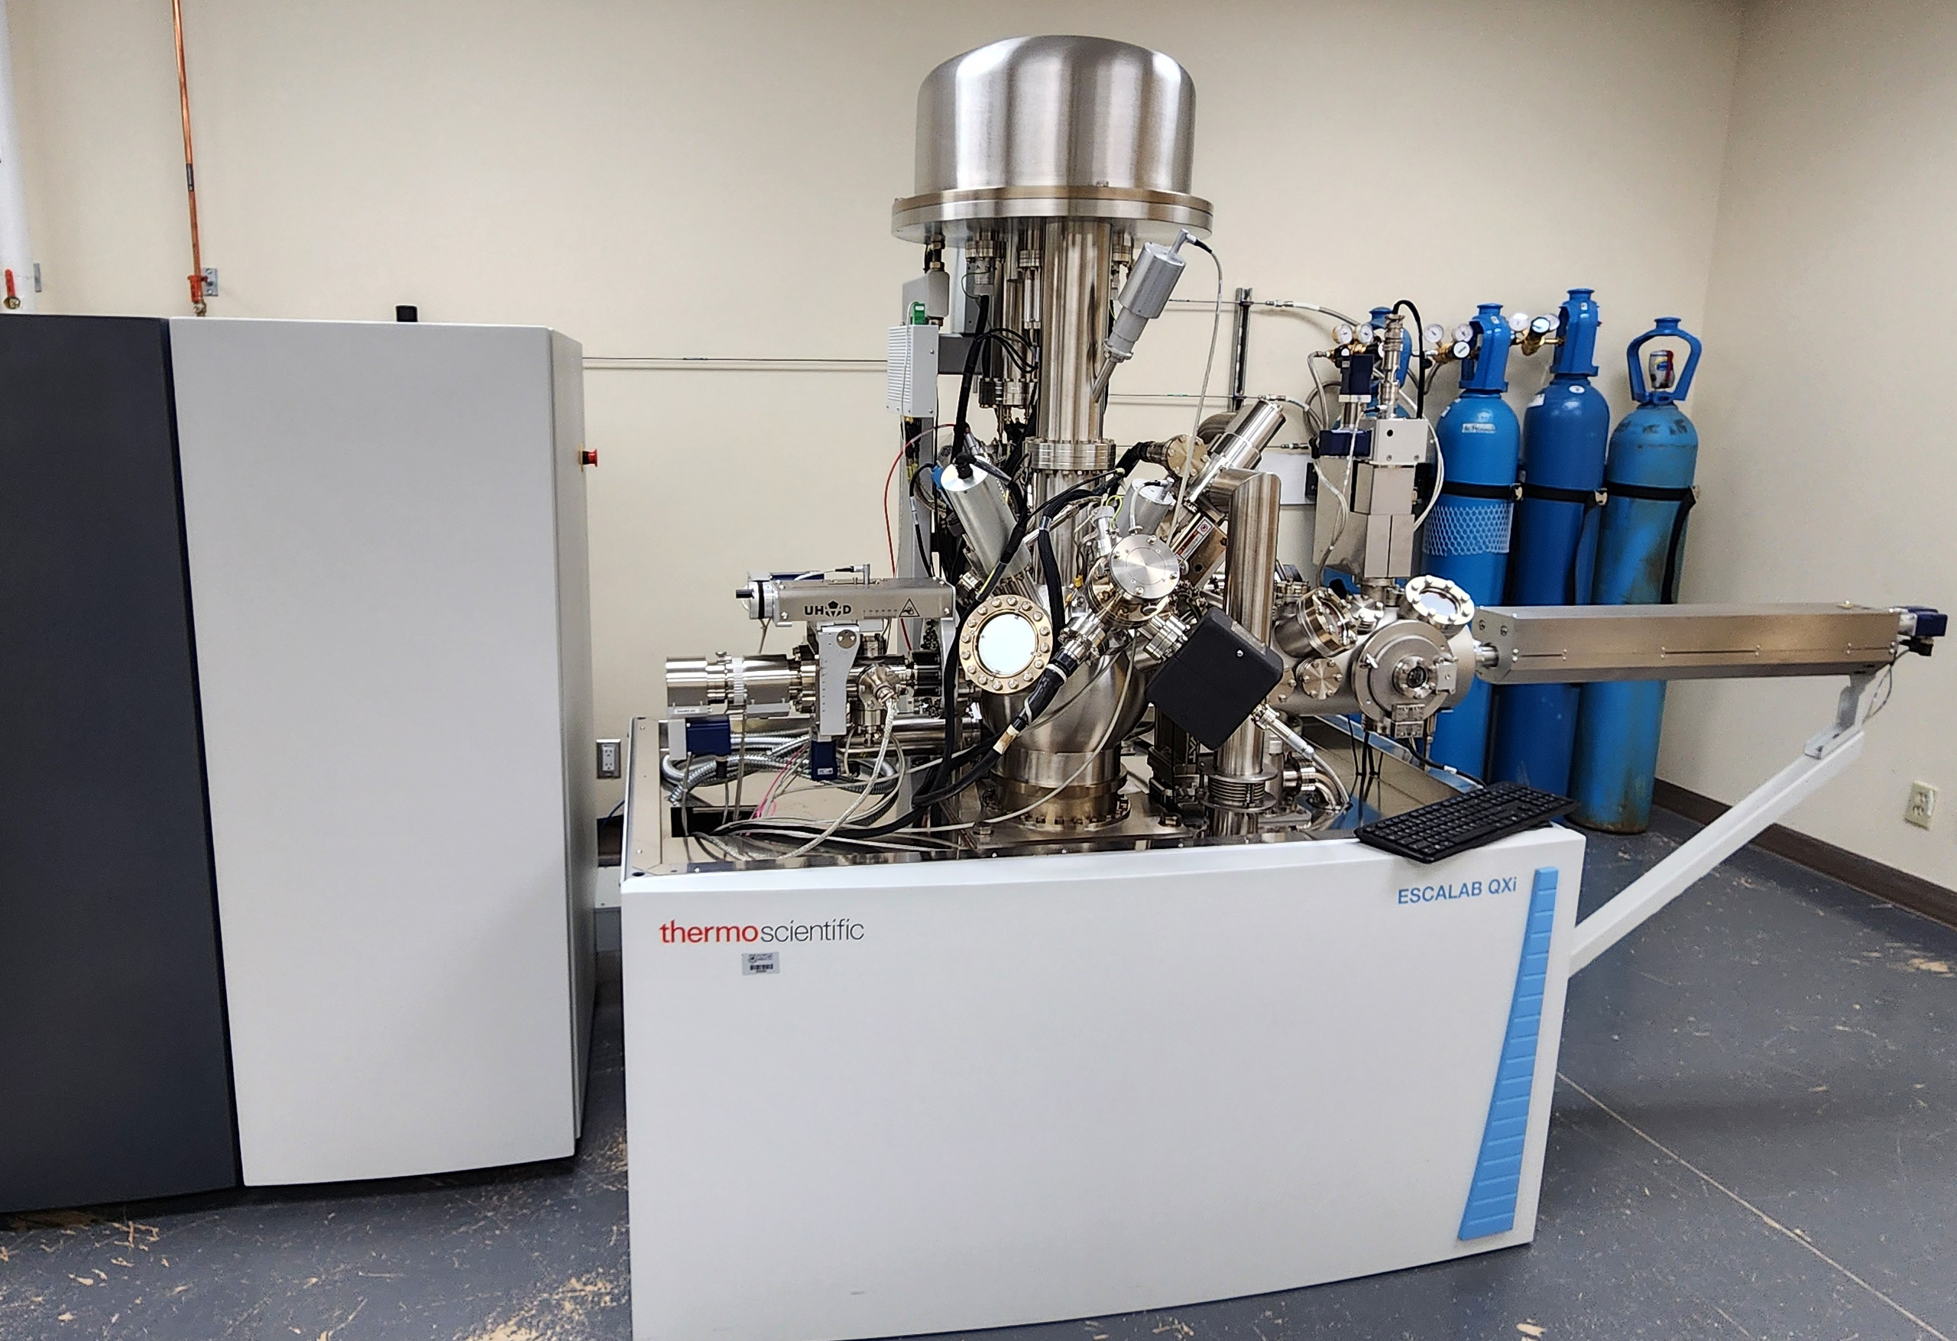  Thermo Scientific ESCALAB QXi XPS Microprobe
Questions or special sample requirements? Contact rad.sadri@ucalgary.ca

